

`

|  |
| --- |
| 2015 International ICT Volunteers  Final Report |

M.P.N.P

Shin Cheeun

Lee Da Youn

Lee Ha Young

Hwang Youn Sun

**PROGRAMME BY**

|  |  |
| --- | --- |
|  |  |

# 1 Introduction

* Introduction of our team

Our team name, M.P.N.P stands for “Meet People, Network People”. This team name contains quite straightforward meaning. We wanted to meet people, and build network among the people we were going to meet. To our gratefulness, just as the meaning of our team name. We could establish friendly network with the people we have met in the dispatched region.

Four university students, all of whom are majoring in information systems in Hanyang University, gathered to make our team for the IT volunteer program. Each member had their own reasons to apply for the program; some had curiosity and excitement to go abroad, while some others wanted to get new experience during summer vacation. Though each member had different interests and expectations when we first noticed the volunteer program, we found out that all of us were deeply moved to do good, meaningful things by sharing our knowledge we have gained from fine education. Furthermore, we thought that by participating in the program, we will be able to give direct support to developing countries which barely have IT skills and infrastructures, making good use of things we have learned from our university major. Therefore we decided to apply for the program together as a team.

We have been sharing a lot of best moments both in our campus lives and off the campus by taking the same courses in college and traveling together during vacations. Various memories and experiences cherished by the four has made our team easy to cooperate during volunteering sessions since we communicated each other based on the powerful bonding which has been created between us has made us. We sincerely share our opinions to solve problems and to overcome difficulties. Our team had another advantage in professionalism during volunteering since all of the members are majoring in academic fields closely related to computer science and information technology. Every member of our team were capable of instructing computer techniques, Internet usage and programming language to students. Even though different roles such as language translation, IT education, and cultural education were assigned to each member, all of us had prepared to be substituted for the team members who are supposed to teach the IT education course, in case those members suddenly become ill or have inevitable reasons to miss the class temporarily. Because of this feature of our team, we could progress IT education sessions without missing any class even when one of the team member was sick.

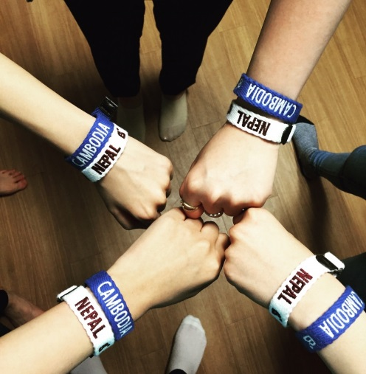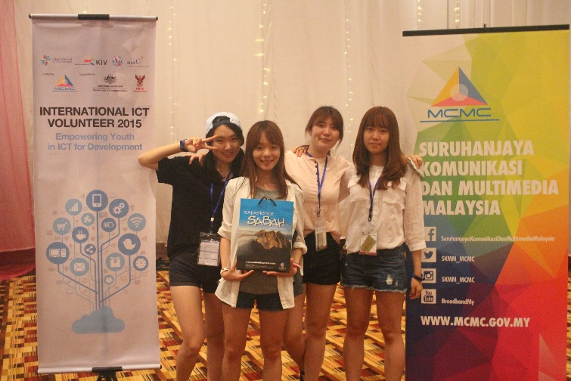

* Introduction of our team members

1. Dayoun Lee

DaYoun was in charge of team’s leader and culture class teacher. She is majoring in information system in Hanyang University. She worked

1. Cheeun Shin

Cheeun was in charge of IT class. She is also majoring in information system in the same university.

1. Younsun Hwang

Younsun was in charge of IT education, as well. She is information system major in Hanyang University, as well.

1. Hayoung Lee

Hayoung was in charge of language translation. Her major is same with the volunteerers abover. As she can take charge of IT education, she taught basic MS Excel and MS Powerpoint in the class. One of Hayoung’s characteristic is that she is punctual person. Therefore, she has helped team members to keep up in time for class or meeting somebody.

* Introduction of the local organisation including contact details of the local people/ogranisation.

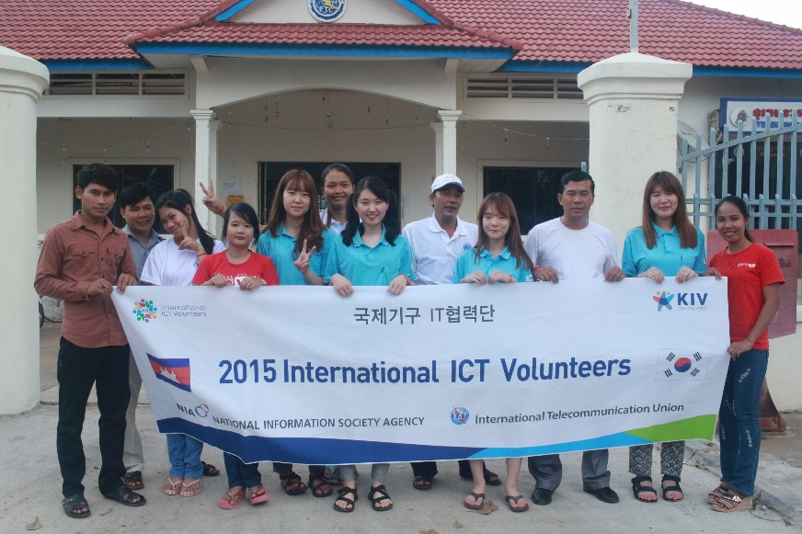Our team’s organization is NIPTICT. NIPTICT is Ministry of Post Office in Cambodia.

We were assigned to work at a post office at Kratie. Kratie is on of the provinces of Cambodia which is located the upper direction to Phnom-penh, being famous for its beautiful sunset and river dolphin.

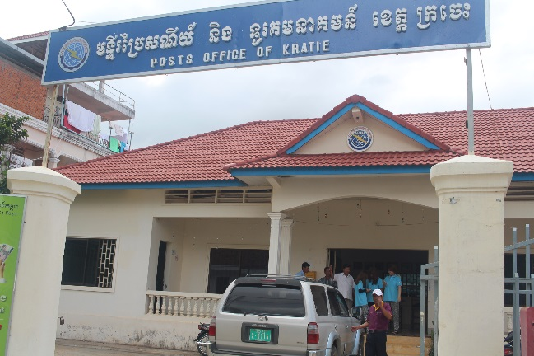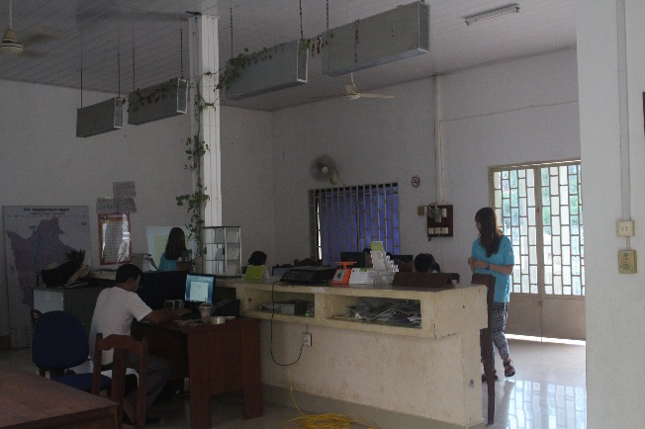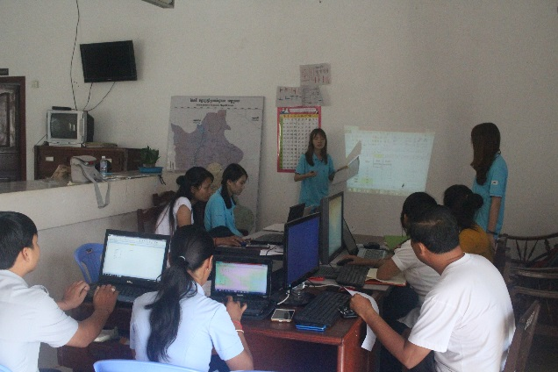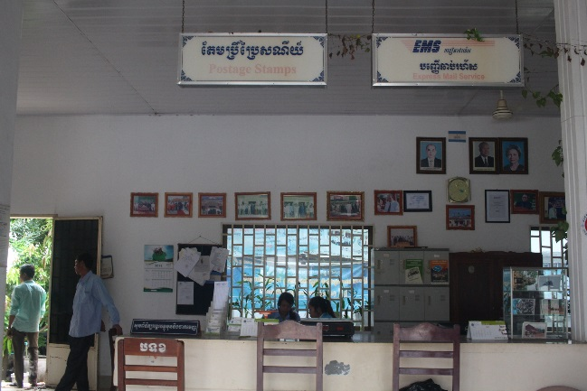

* Overview about local environment including hotel accommodations, food stalls, local transportation (this information will be useful for future volunteers)

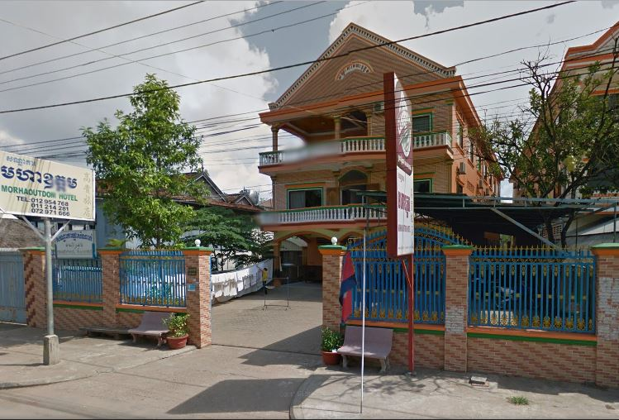 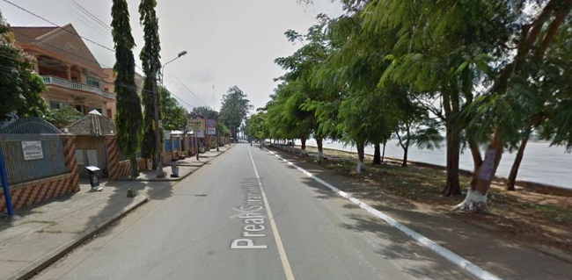

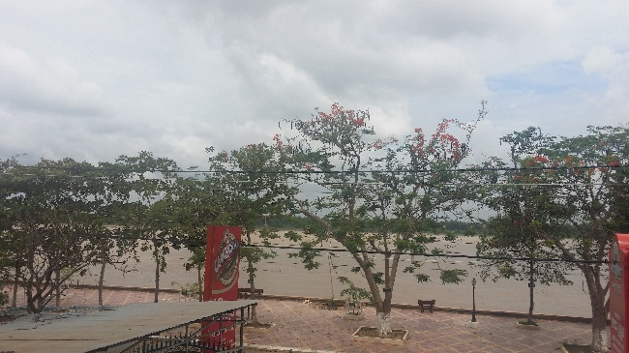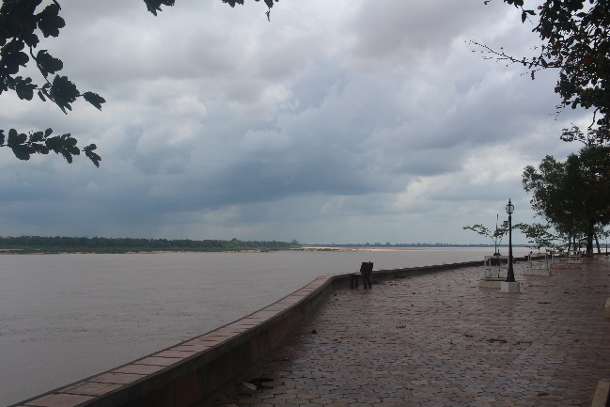

These are some pictures we took near our hotel. Since Kratie is a province developed near Mekong River, the hotel we have stayed was also located right beside the river. Every week, from Monday to Friday, we rode on our bikes for about less than 5 minutes to get to the post office where we have worked.

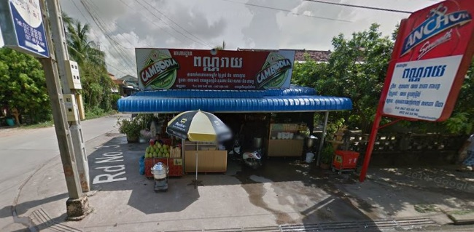This restaurant is that our team used to have a dinner in Kratie. Price was very cheap. In total, we only paid 1$ for rice. With this rice, we ateit with Korean side dish can that brought from Korea

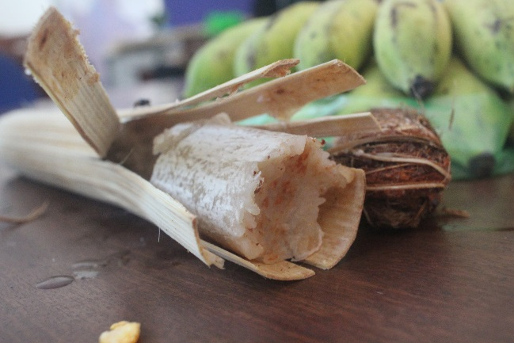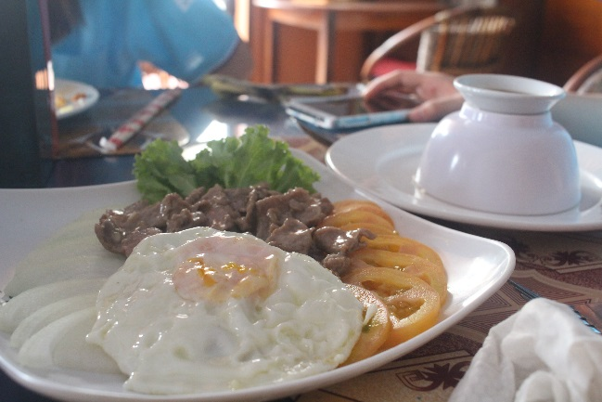

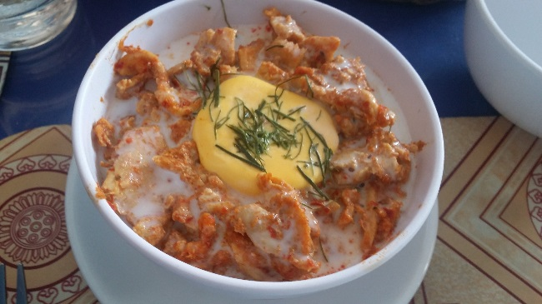 These are some Cambodian tranditional dishes that we have tried. They are Kro-lan, Loklak and Amok. All of these dishes had its own special characteristics which made us felt the true flavors of Cambodia.

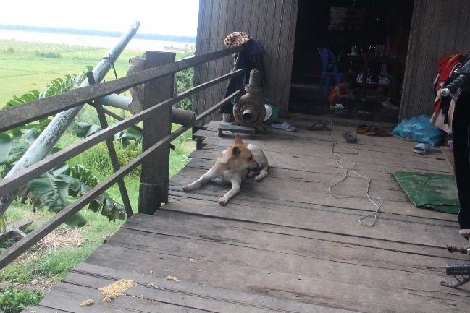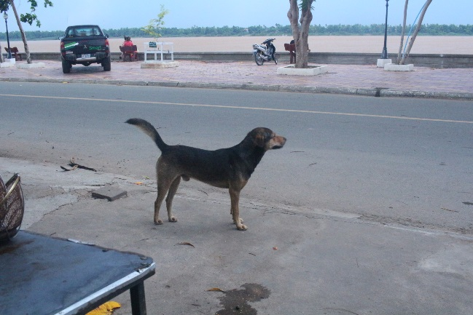

Many dogs live in Cambodia. They strolled through almost every restaurants. Most of dogs were very big. As we took a lesson that being careful of rabies is important, we were very afraid of these dogs. However, as time went by, we found that dogs also tried to avoid humans.

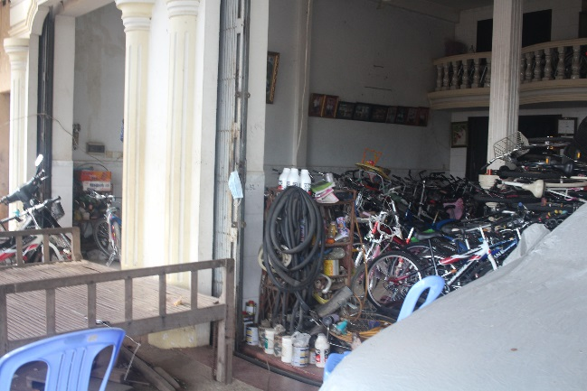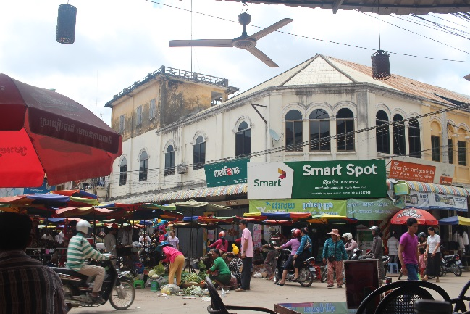

Cambodians usually ride motorcycles to move from somewhere to another place, but sometimes they use bicycles. We have rent four bicycles for 40 dollars and rode them to go anywhere in Kratie.

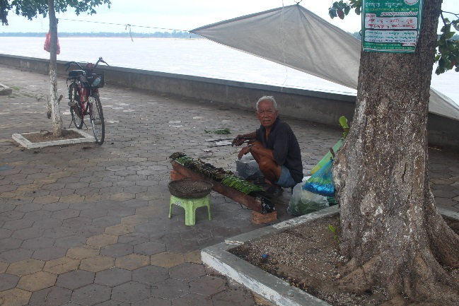This is the food that fired mix of rice and banana covered with banana tree leaf. One old men was selling it in front of our hotel . Not only this, many foods are sold at the road such as grapefruit, krolan, and baguette.

# 2 Activities

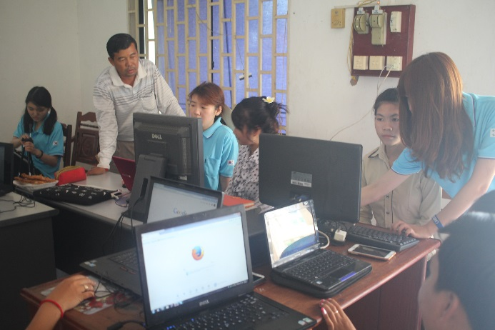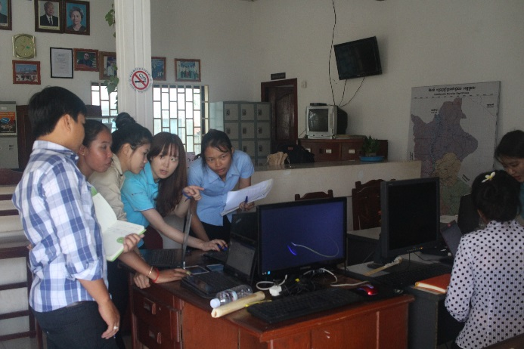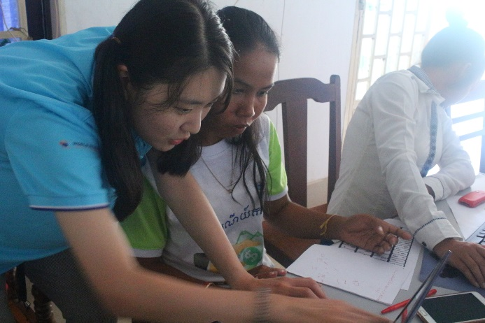

At the first time we met the students, we asked them what they wanted to learn. They told us that they wanted to learn Microsoft Excel, Microsoft Powerpoint, and photoshop. Based on their replies, we specified our education program.

We proceeded with IT education classes from 8 am to 11 am based on our schedule and the requirements of the students. We basically taught three things; Microsoft excel, Microsoft powerpoint and photoshop. Students learned how to use useful functions during excel classes. They also learned how to make effective presentation slides in powerpoint classes, and learned how to edit images they can use in various situations through photoshop classes. Sometimes, we informed them about some useful websites and functions they can use on daily office work such as Google Drive and Google docs.

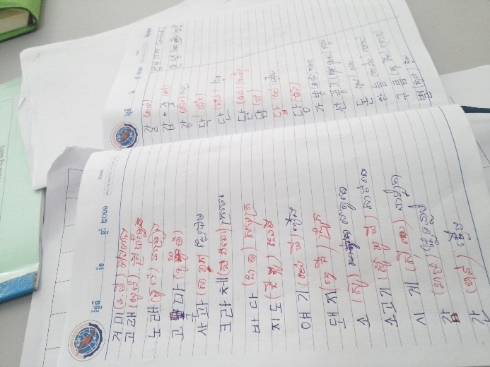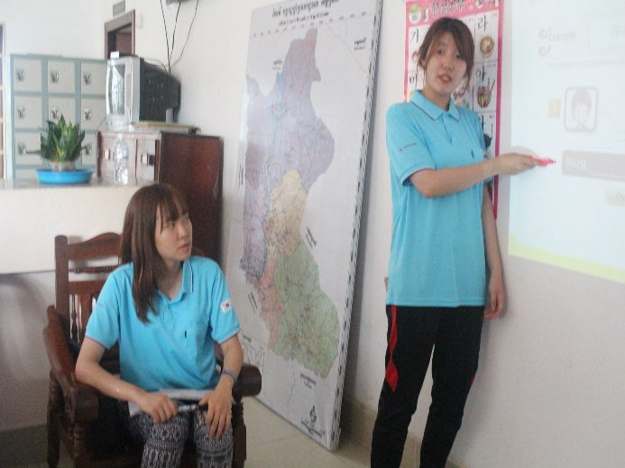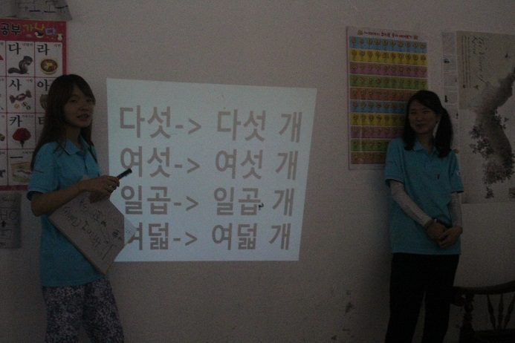\

Culture classes also took place every Monday to Friday, from 3pm to 5pm. Since students’ eagerness to learn Hanguel was the foremost one, we modified our schedules a little bit to make the classes more concentrated on Korean Language education. To begin with, we taught how to read, write and pronounce vowels and consonants. After students became familiar with the letters, they learned how to greet, count numbers, and buy something in Korean. Also, we have brought small brush pens for students. They wrote several expressions they learned before with those brush pens. We have prepared some materials to play Korean traditional games such as Gong-gi and Yut-nori, as well. All of us had an enjoyable time, playing the games altogether.

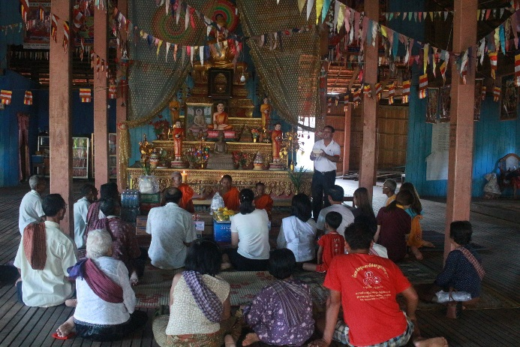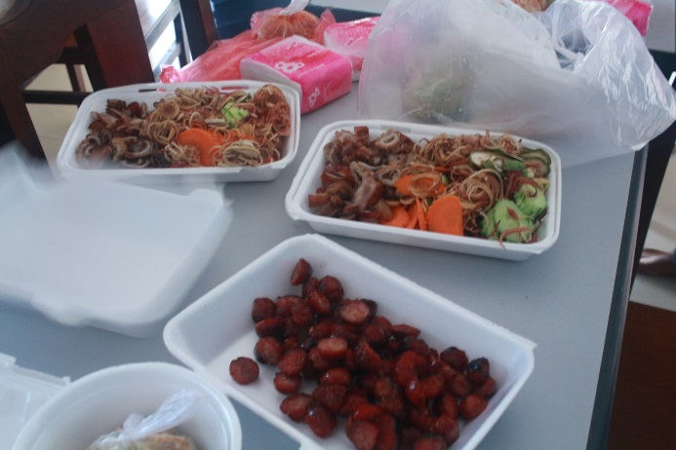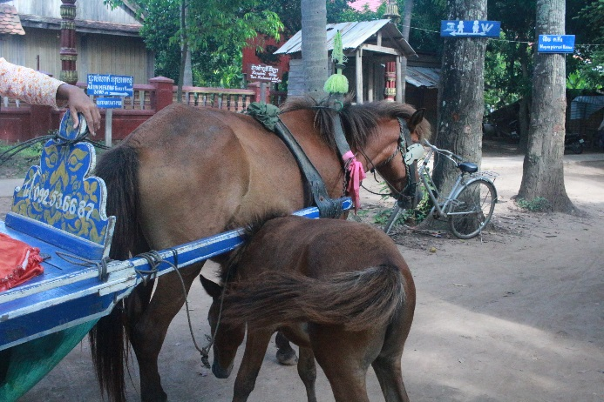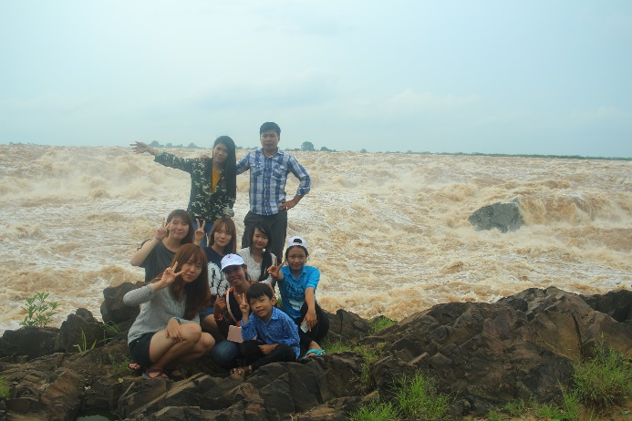 On weekends, post officers took us to some beautiful places in Kratie and we had a time to experience various aspects of Kratie. We went to several temples, the upper stream of Mekong river and the island located near Kratie. We had a lot of fun and created cherishable memories with the officers.

# 3 Deliverables

**Guidelines:** This section elaborates achievements/work outputs that the team has made. For instance, if a software application is developed, the authors should explain how the programme is developed and how to use it. If a website is built, then the authors introduce the URL and describe key features of the website.

엑셀하는 모습 뒤에서 찍은 사진, 수업자료, 포토샵 만든 사진, (설문조사 한 거 통계조사 차트), 한글쓴사진

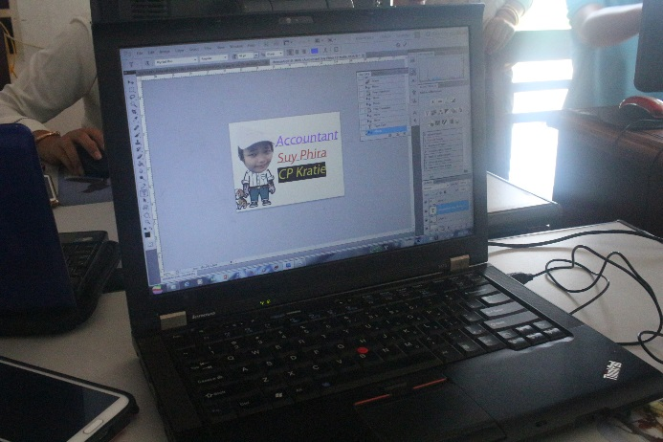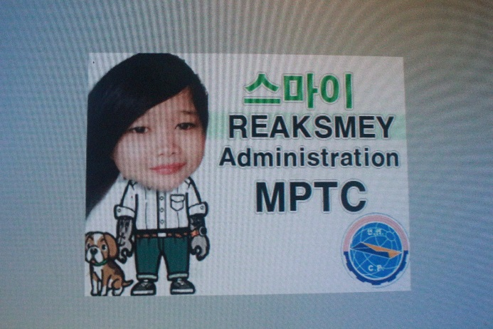

In photoshop class, we had a time to make one’s own name card. During this time, students could review that they learned before in the class such as photo modification and photo combination. At first, they were hard to practice well. However, as we taught again and again, they could do it themselves and enjoyed a lot.

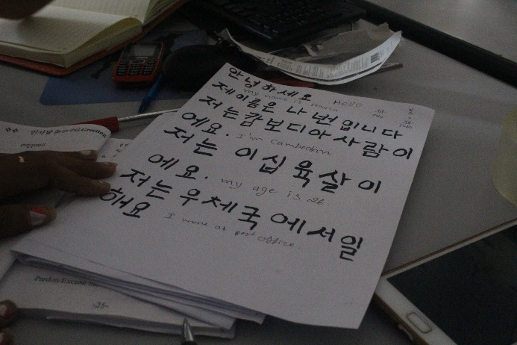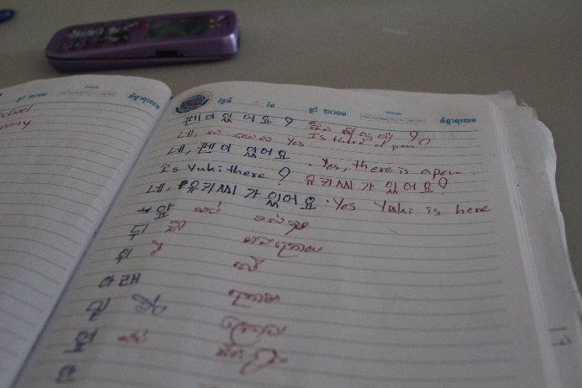

In Hangeul class, students were very passionate. Everytime, students took a note that they were learning. They wrote every words and sentences in their notebook. Also, we had a time to write Hangeul with Korean traditional brush pen. They were very interested in it and wrote their own sentences sincerely.

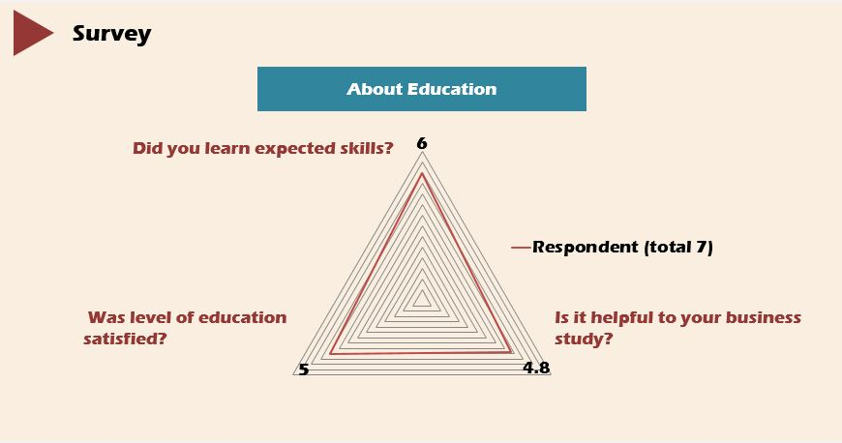After class, we had a time to have a survey. The number of respondents were total 5 and all of their age boundary is from 20 to 29. Also, all of their last education level is college or university. First, about education part, we asked 3 questions. 1. Did you learn expected skills? 2. Was level of education satisfied? 3. Is it helpful to your business study?

As perfect score is 7, we got high score at every questions except third one. Most of students said that our class is not very helpful to their business work. We regard this result that we should have taught them application of basic skill.

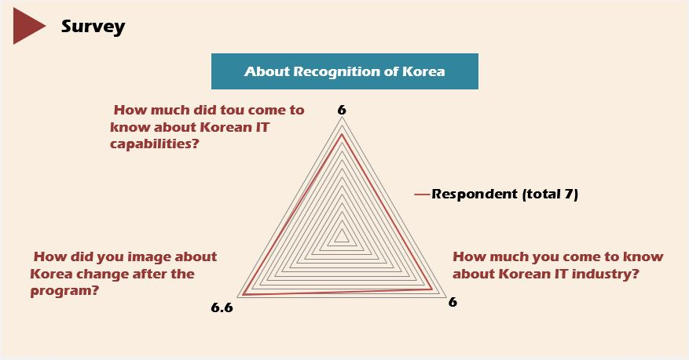

About recognition of Korea, we also had 3 questions. 1. How much did you come to know about Korean IT capabilities? 2. How did you image about Korea change after the program? 3. How much you come to know about Korean IT industry?

In this part, we got nearly perfect score at every questions. That is, we successed to introduce Korea.

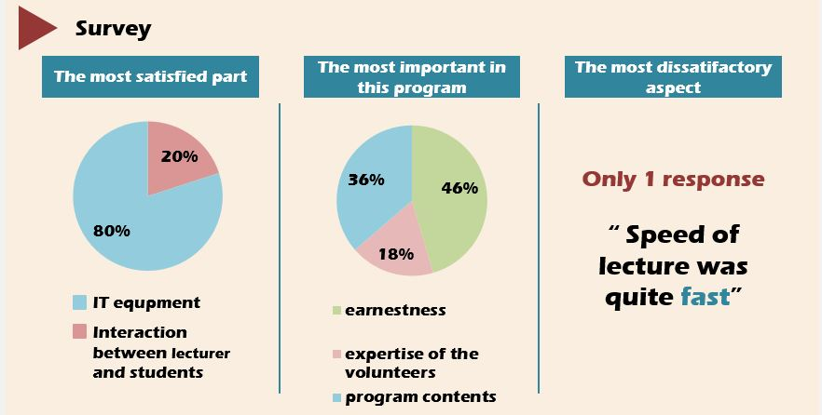

We also asked them to other questions such as 1. The most satisfied part 2. The most important in this program 3. The most dissatisfactory aspect. About first question, they responded that interaction between lecturer and students was the most satisfied. Next, about second question, they regarded willingness of students and program contents as the most important in this program. Third, except one students, they responded that there were no dissatisfactory part in our program. However, one students said that our speed of lecture was quite fast to follow.

# 4 Issues, Challenges, and Recommendations

Guidelines: It is important that the authors draw lessons learned from their own experience and share them in this report. These lessons include issues and problems they encountered. Some recommendations may also be proposed.

교훈…남을 돕는게 결국에 나를 돕것이다~ 윤선왈

다른 문화를 받아들이고 이해하는 것에 대한 어려움 (음식, 웃통 벗고 다녀서 깜놀, 오토바이 세네명, 자동차의 역주행, 윤선이의 표정관리의 관맄ㅋ, 소피엡의 노잼)

사람사는데에는 똑같구나 채은왈

정전, 컴퓨터의 부족함, 인터넷이 잘 안됨, 장소의 협소함 그러나 학생수가 적어 큰 불편은 없었다. 그러나 영업장에서 수업을 해서 중간중간 시끄러운 소음들이 수업을 방해, 빔이 너무 밝아서 잘 보이지 않았다.

다른 부서들에 참여를 물었으나 낮은 참여도.

교육자료의 급 변환? 엑셀을 할 줄을 몰랐다.

팀원의 설사, 토, 방귀~